# Week 4: Level 1 (Fun With Photoshop)

# Objectives

1. Main objective: select images from the folder named (Session Images) on the memory stick and using the ARTISTIC FILTERS, experiment with the many art effects for converting your images into a painting or drawing. (YOU CAN USE YOUR OWN IMAGES IF YOU WISH).
2. Use the LIQUIFY TOOL to create caricatures of cats, dogs anything really goes here! It’s just for fun.

3. Collate all your creations on to a series of new templates (pages) for your final portfolio.

# Outcomes

1.You will learn about the many different pre-set art filters and make a judgement as to which is the best effect for normal photography use.

2. You will have a lot of fun mastering the LIQUIFY TOOL creating strange images that are OUT OF THIS WORLD!

**TASK 1**

Open the image named baby1.jpg from WEEK 4 session folder.

You will have to open any images using **BRIDGE** – find your USB/drive then the folder.

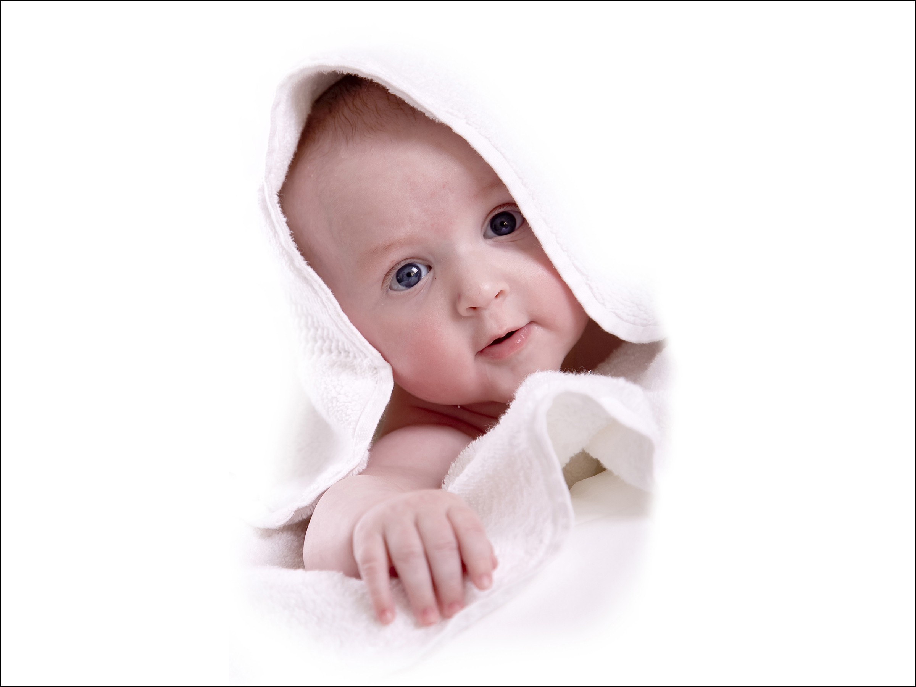 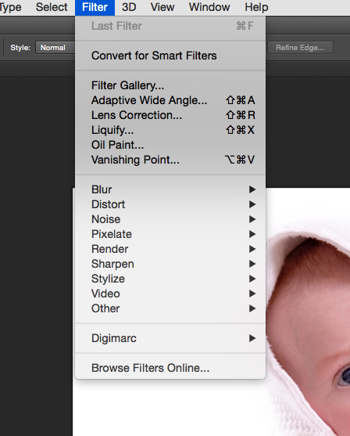

**Go to the menu at the top of Photoshop and choose Filter – Filter Gallery -**

Once you have selected the FILTER GALLERY correctly, a new window opens revealing the many pre-set artistic filters ready for use. (see image below).

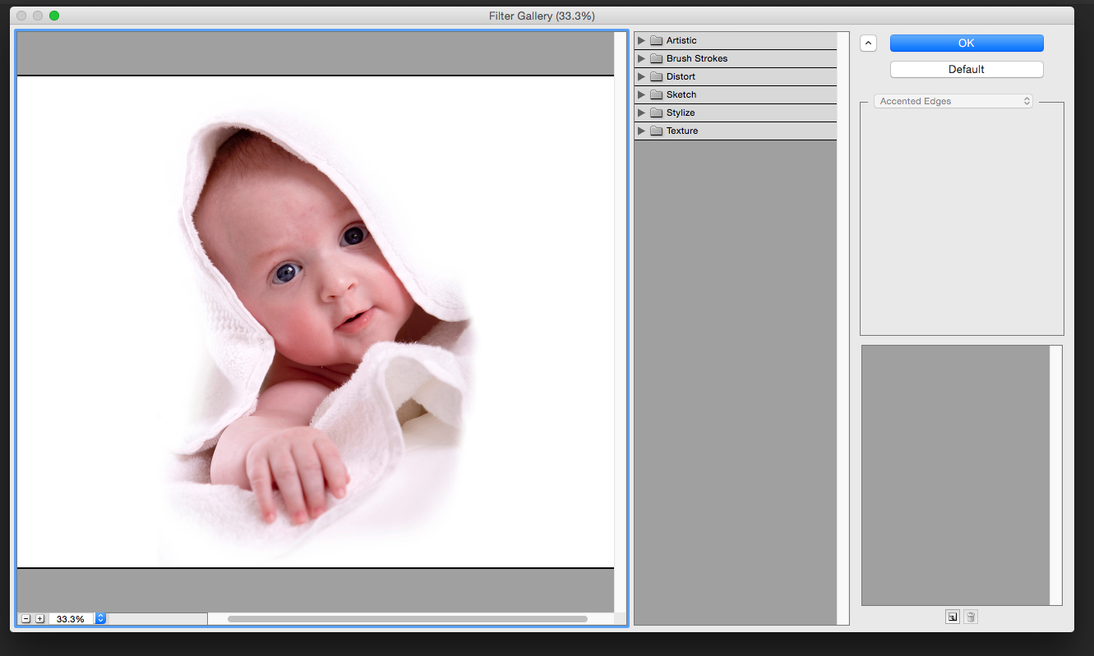

If you don’t see an image in the window – change the percentage view option at the bottom left of the pane using the - + buttons. Try 33% or less.

**STEP 2:** Experiment with the different filters

Click on the menu – Artistic – Poster Edges: This creates an instant drawing effect.

Now try the Neon Glow effect … change the colour of the blue to something like red or pink and move the effect sliders.

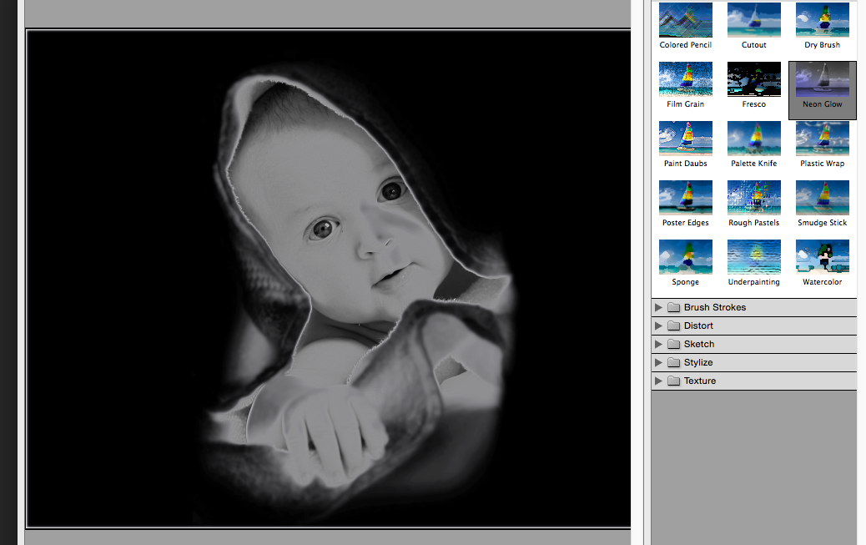

If you want to try a different filter just move on to any of the small images within the sets … experiment with any of these and find the combinations that you like. When you like what you see ***press OK to load this into the NORMAL PHOTOSHOP WORKSPACE.***

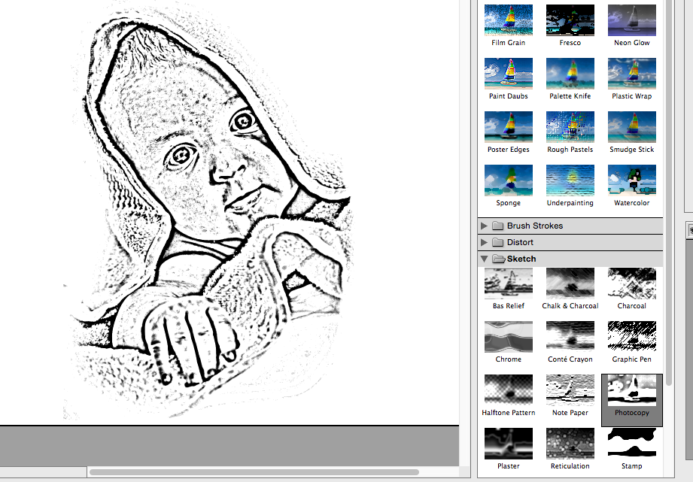 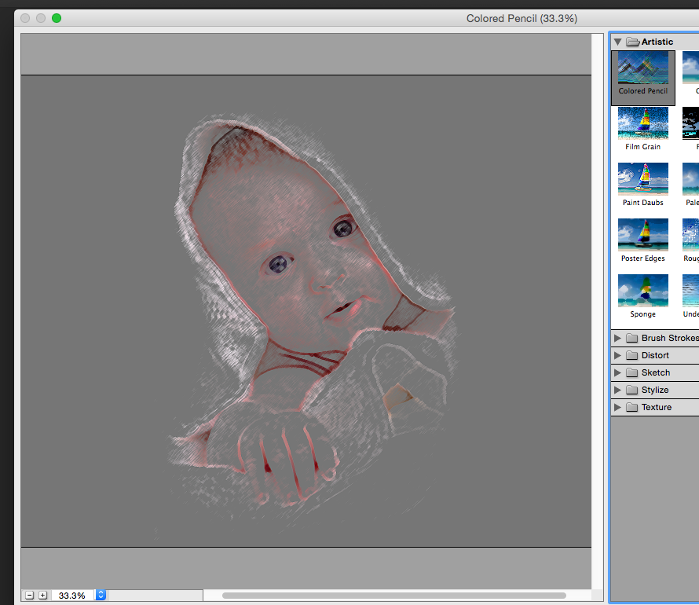

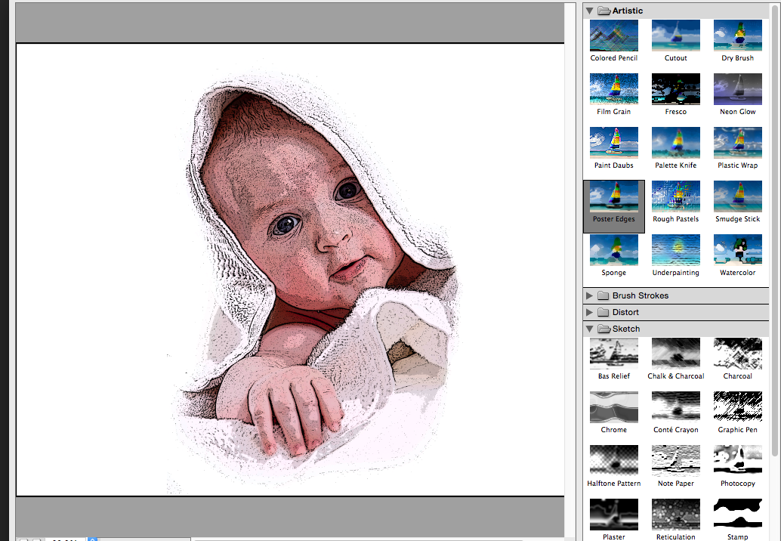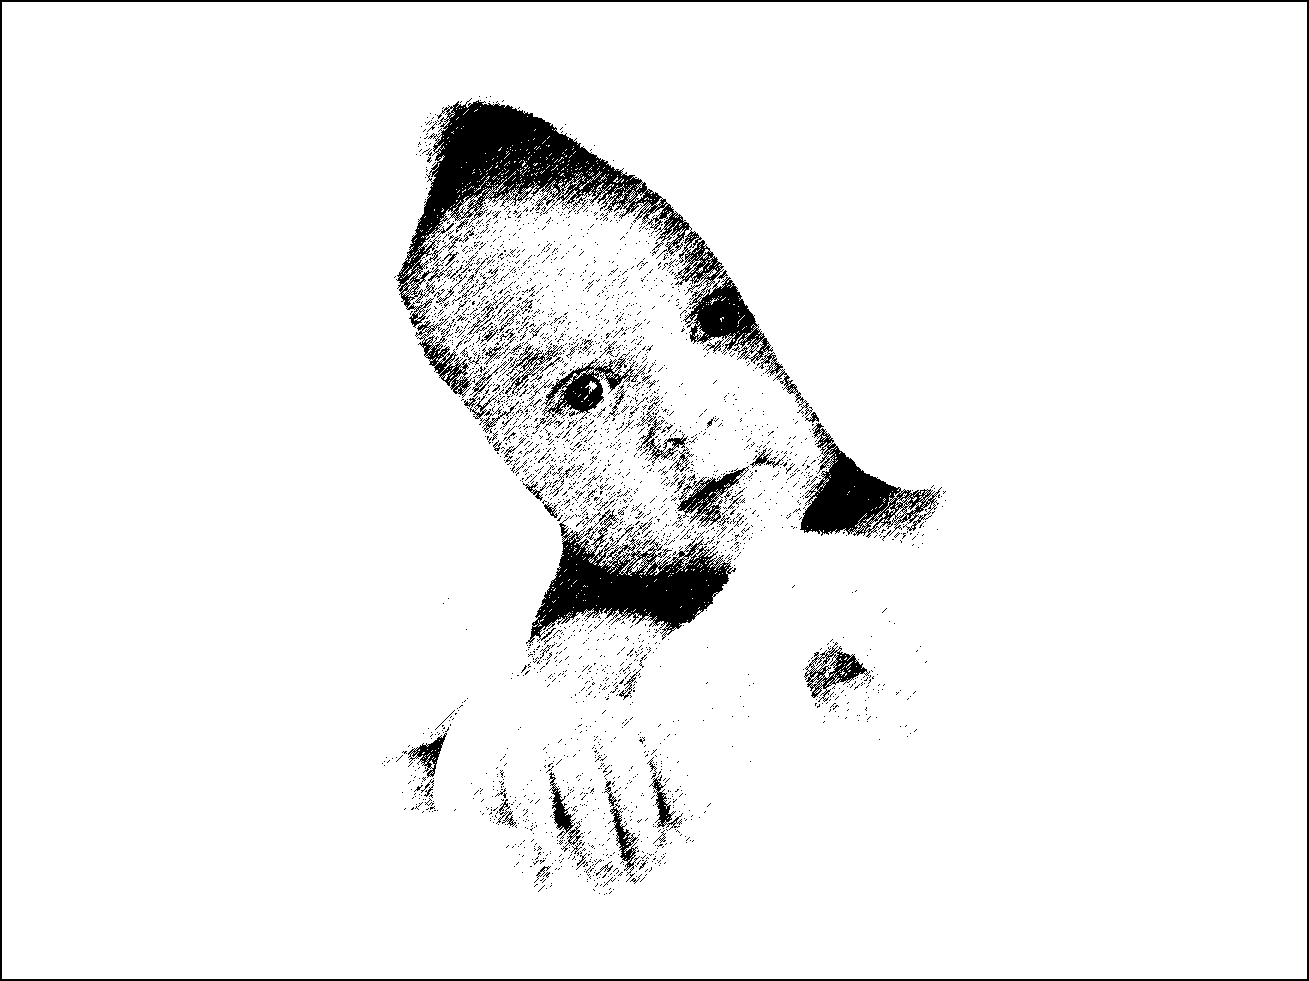

My favourites are: Neon Glow, Poster Edges, Chalk and charcoal and watercolour.

When you have produced a number of art effects put them onto a new templates.

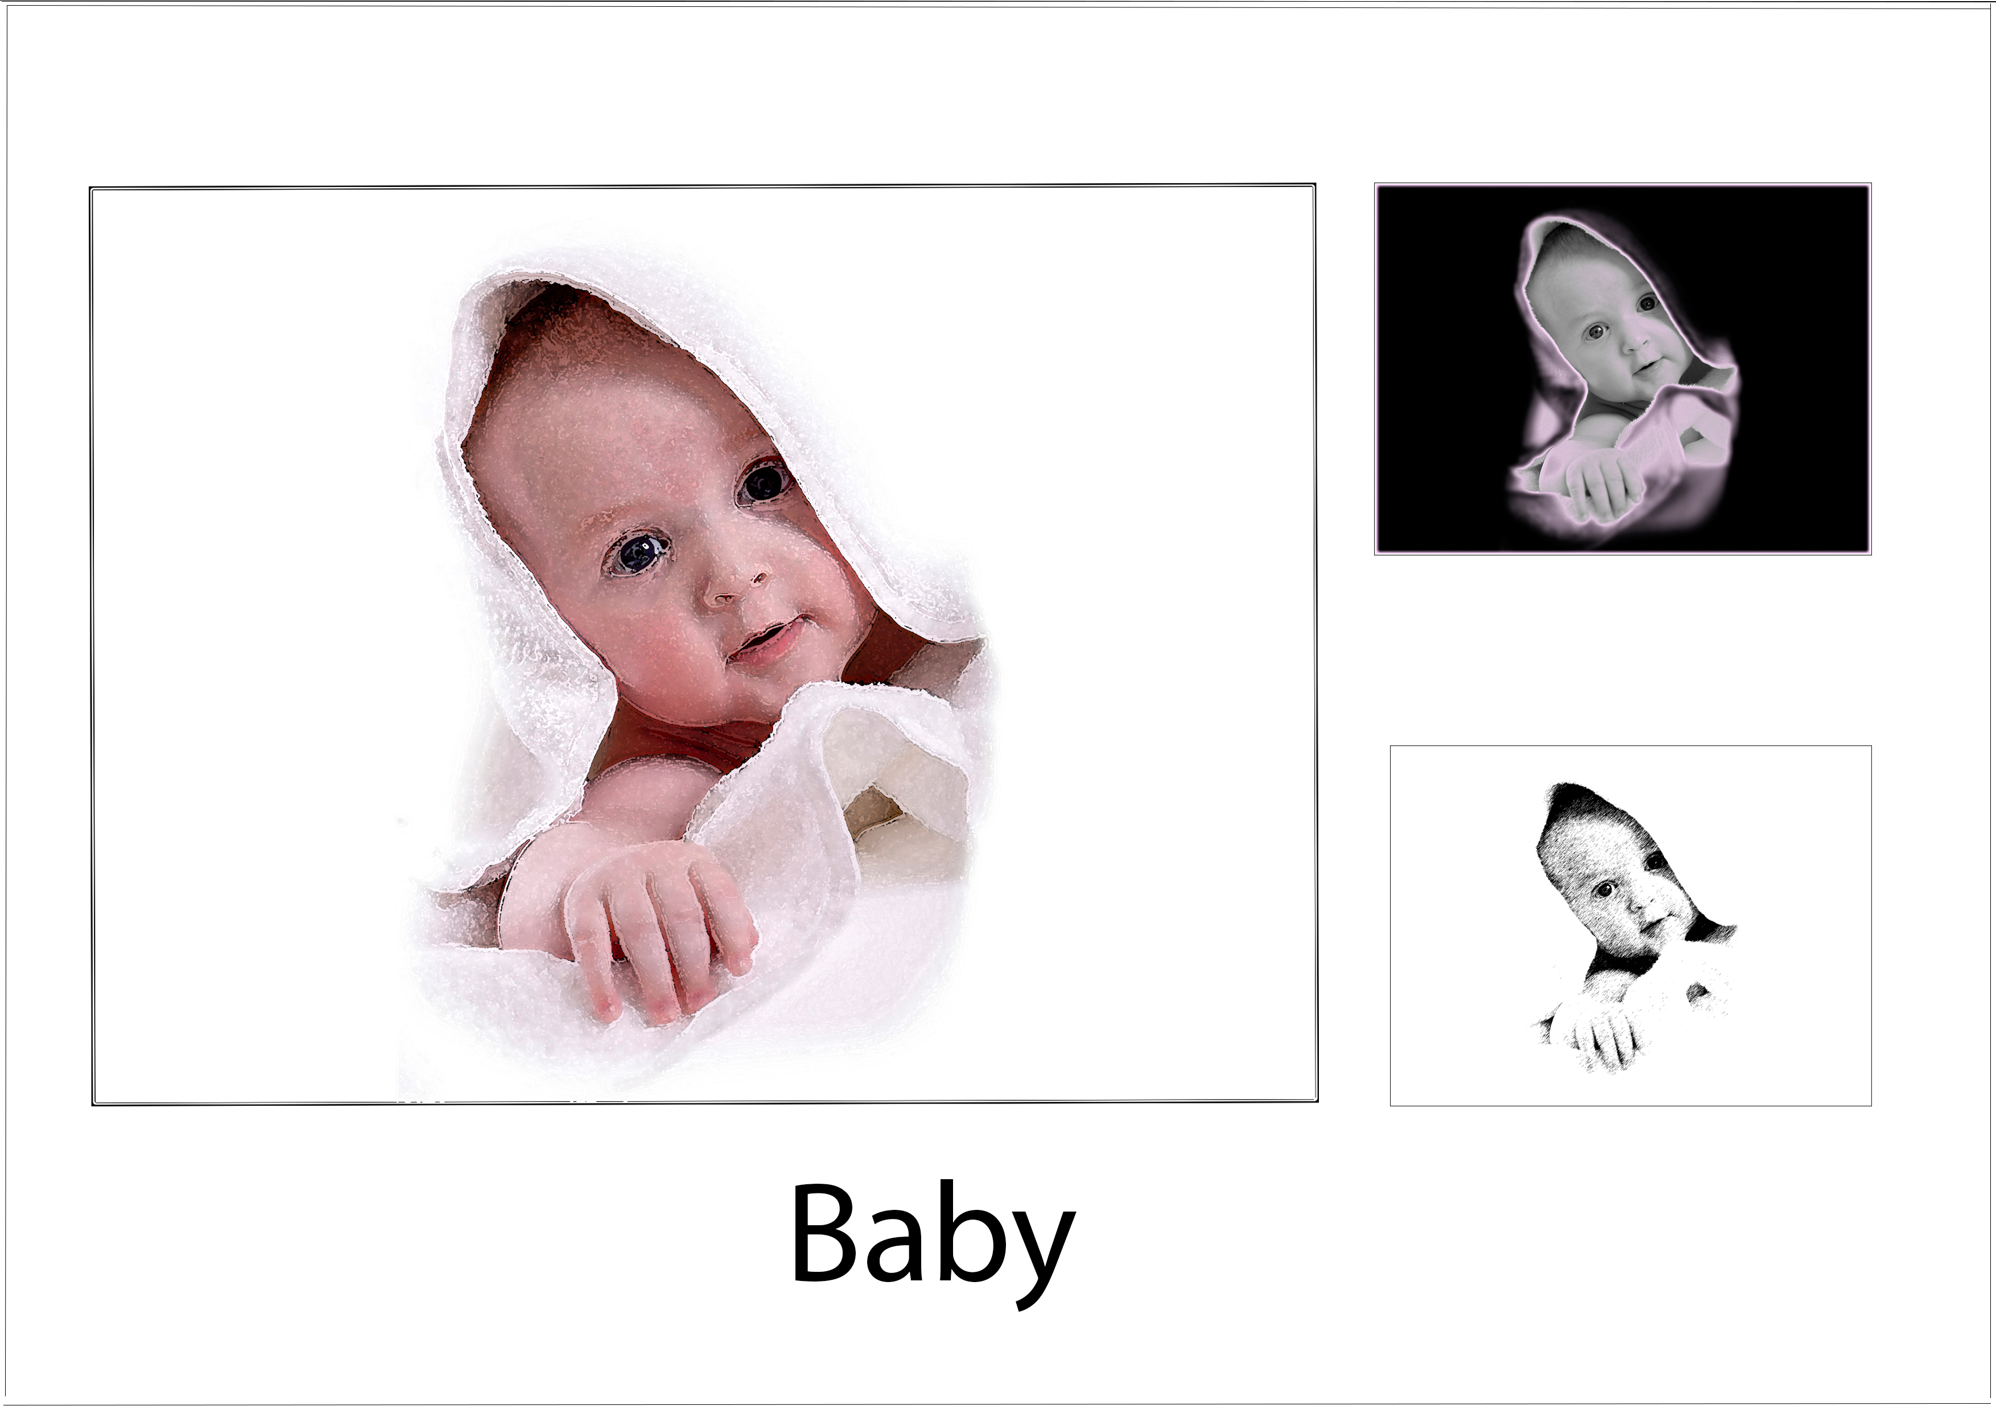

When you have pasted all your images onto one template try using the TEXT TOOL.

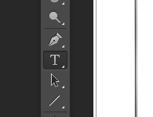

Simply pick up the tool from the Photoshop TOOL BAR on the left and click on the image area where you would like the text to be. (See me for in one to one tuition on this).

**TASK 2:** THE LIQUIFY TOOL

**WARNING!** The liquify tool was designed to be an aid for distorting and melting effect. Unfortunately it has been over used in the fashion industry and magazine industry by helping already size 0 models to look even thinner due to the nature of the application of the Liquify tool.

Any use of the liquefy tool on people must be used with a sense of responsibility on behalf of those using it in Photoshop. I do not recommend the use of this tool to create caricatures of friends and people you may know and distribute them on public networking sites. REMEMBER! Some people could take offence if their image has been distorted without their permission even if you took the image as a photographer and you are the owner of the copyright.

CHOOSE THE LIQUIFY TOOL FROM THE DROP DOWN MENU ABOVE. **Filter – Liquify**

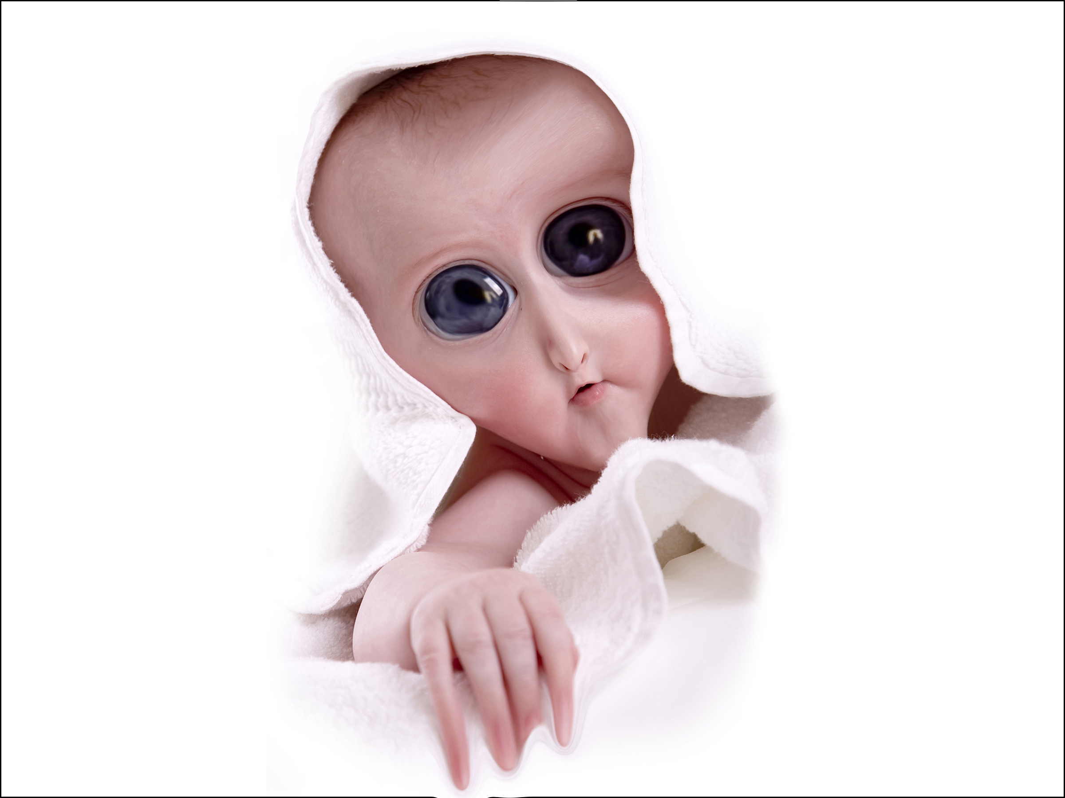

the liquefy tool is very simple to use … just change brush sizes and experiment by pushing out areas and expanding the image form to get the desired effect. Practice makes perfect.

**HAVE FUN!**